June | 2018

Elementary Strings Program/Piano Group
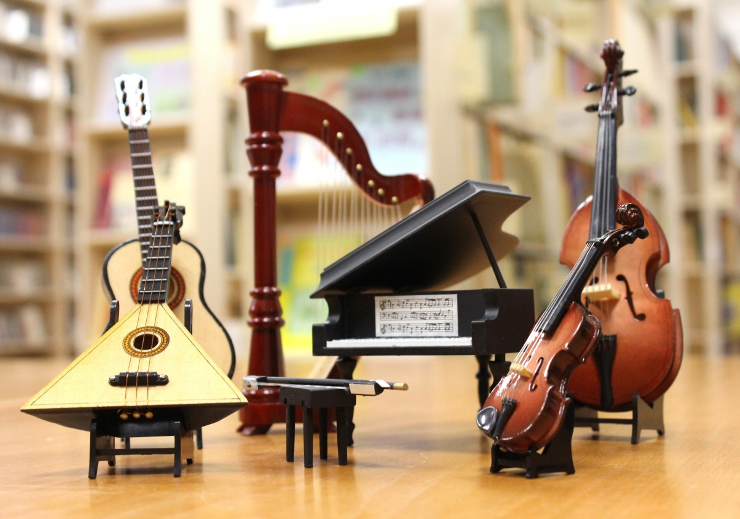
Sunday | Monday | Tuesday | Wednesday | Thursday | Friday | Saturday
 |  |  |  |  | 1 | 2
3 | 4 | 5 | 6 | 7 | 8 | 9
10 | 11 | 12 | 13 | 14 | 15 | 16
 | Piano Group 2pmto2:50pm | Elementary  1pm- 3pm | Strings | Program |  | Piano Group 2pmto2:50pm
17 | 18 | 19 | 20 | 21 | 22 | 23
24 | 25 | 26 | 27 | 28 | 29 | 30
 |  | Elementary  1pm-3pm | Strings | Program

